How to install :

Open Google Chrome, go to settings tab

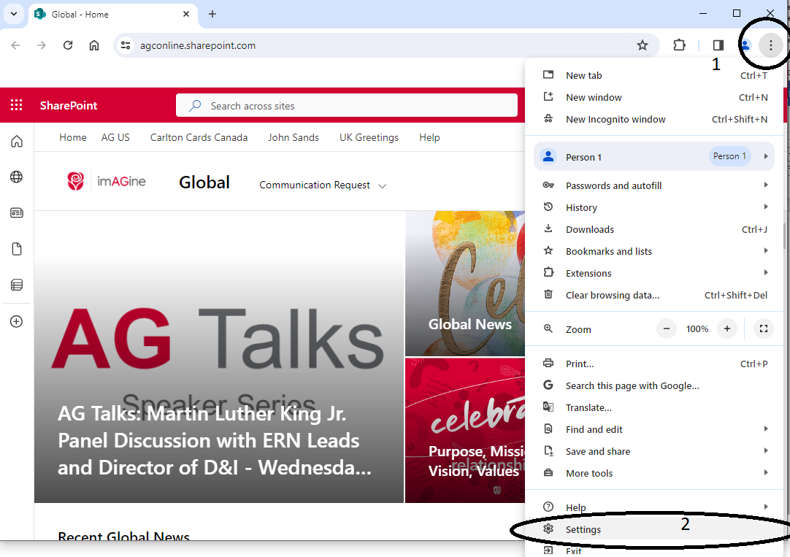

Open extensions list

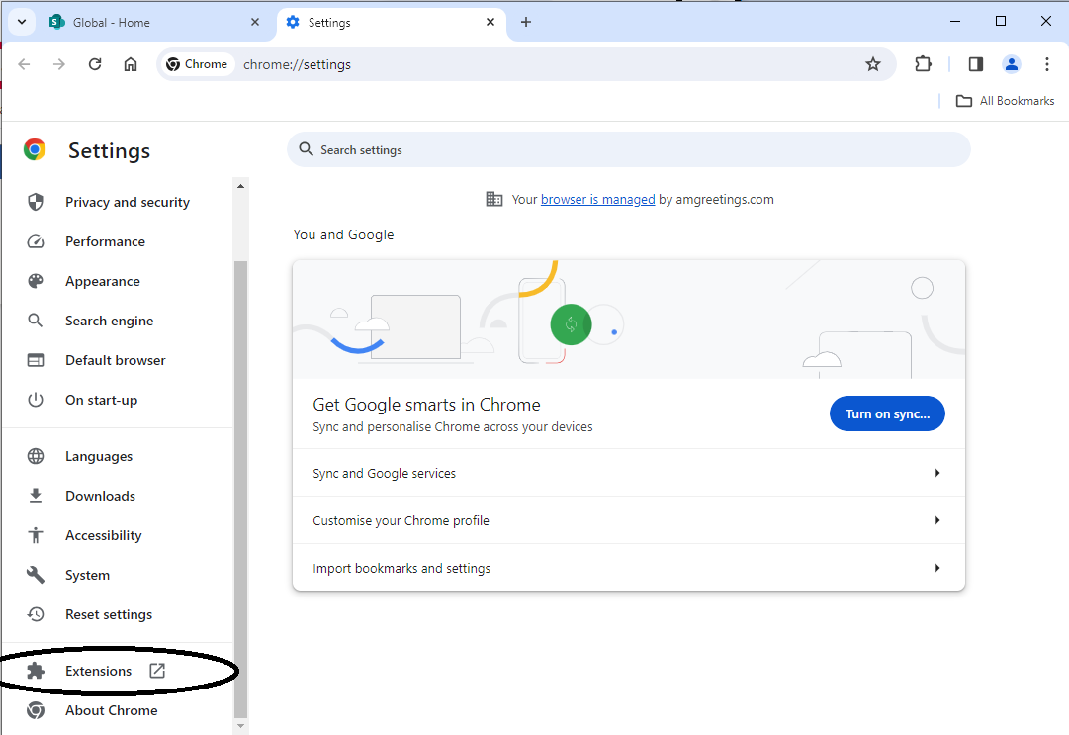

Enable Developer mode, then click Load unpacked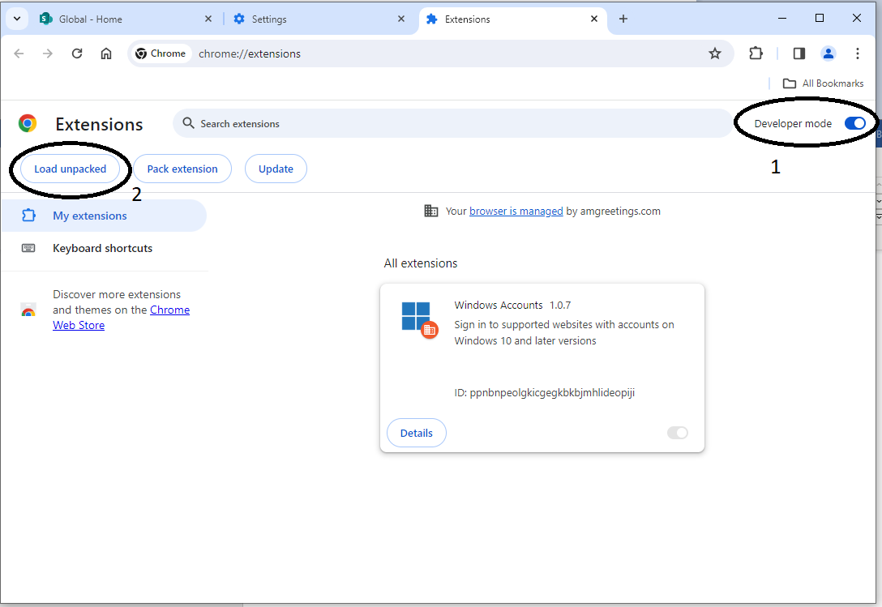

Navigate to

\\ukdews309\usw\bart\chromeExtension and click Select Folder

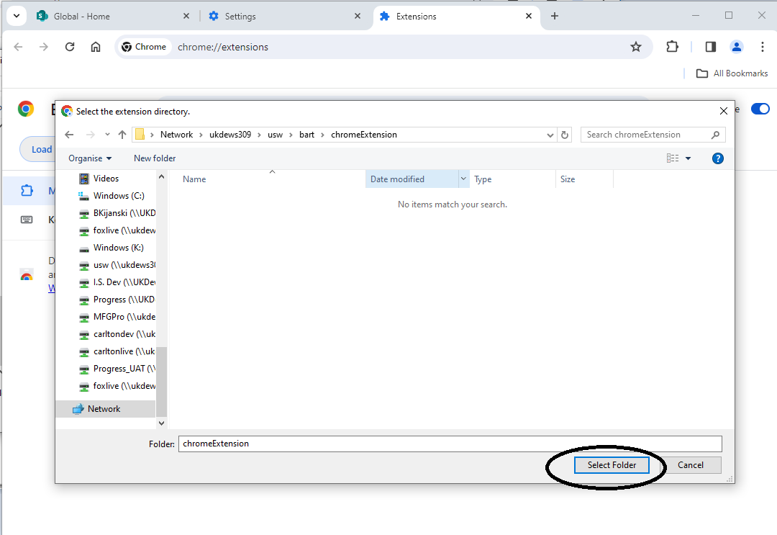

The extension is now added to your browser.

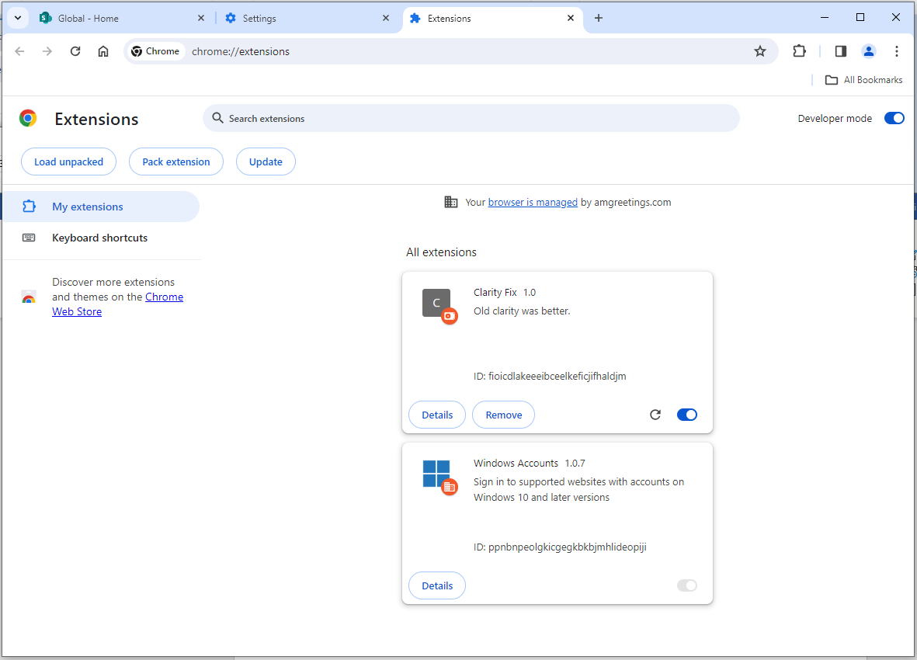

Log in to clarity, select your timesheet

Once on your timesheet view click little puzzle icon on right side of address bar, then select Clarity Fix.

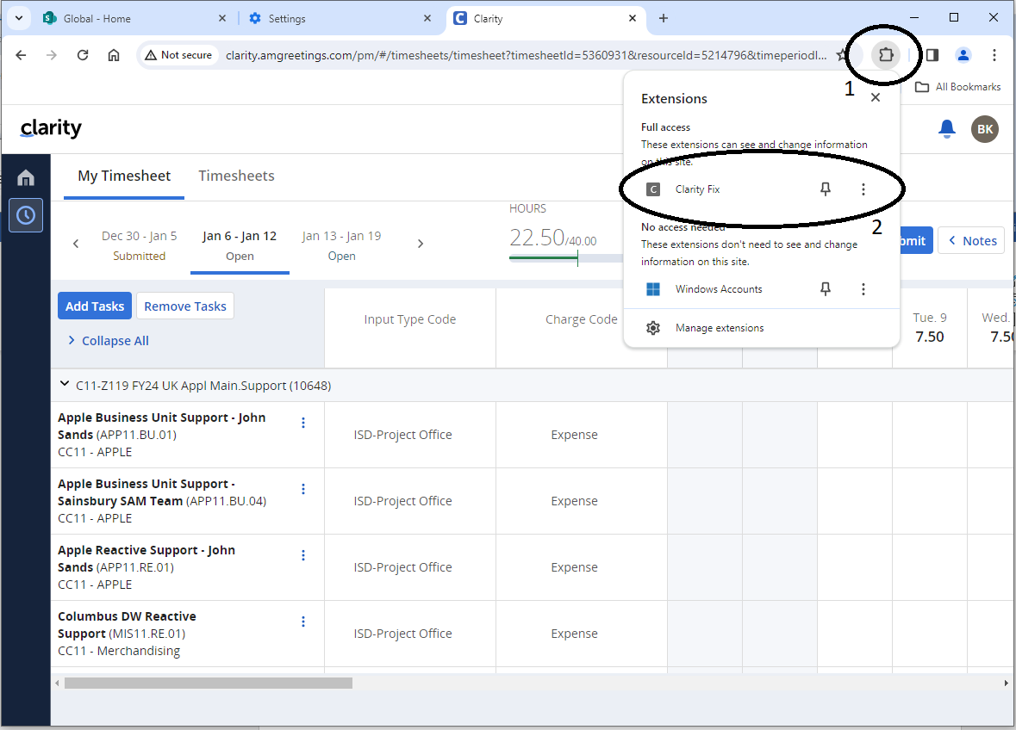

You should now see “Resize Clarity” button, click on it.

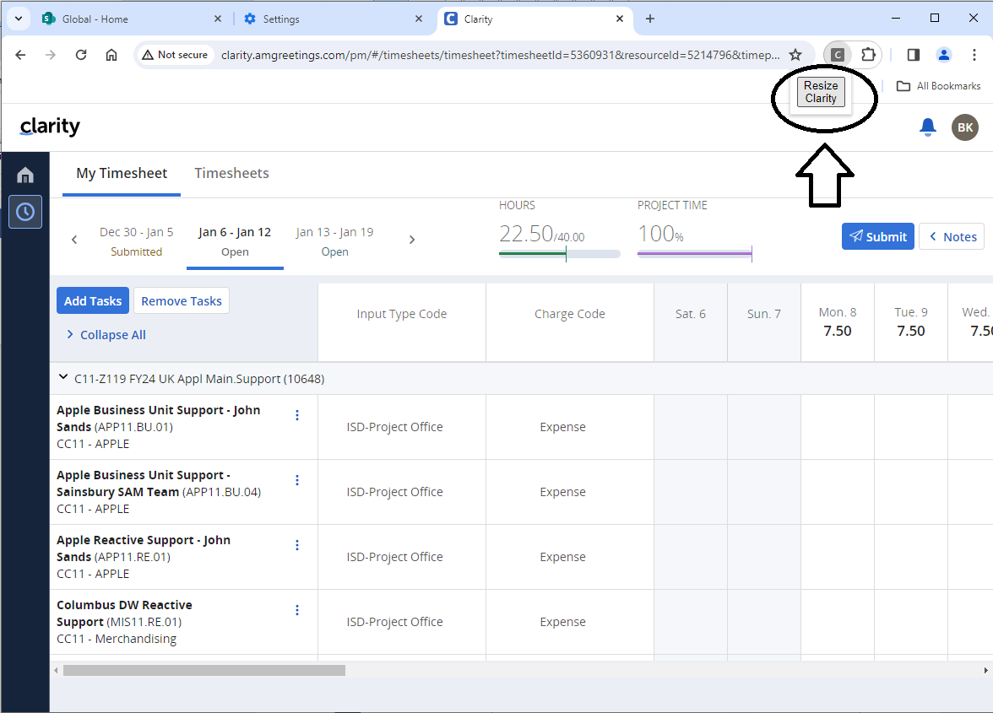

It should drop every column after “Short Name”

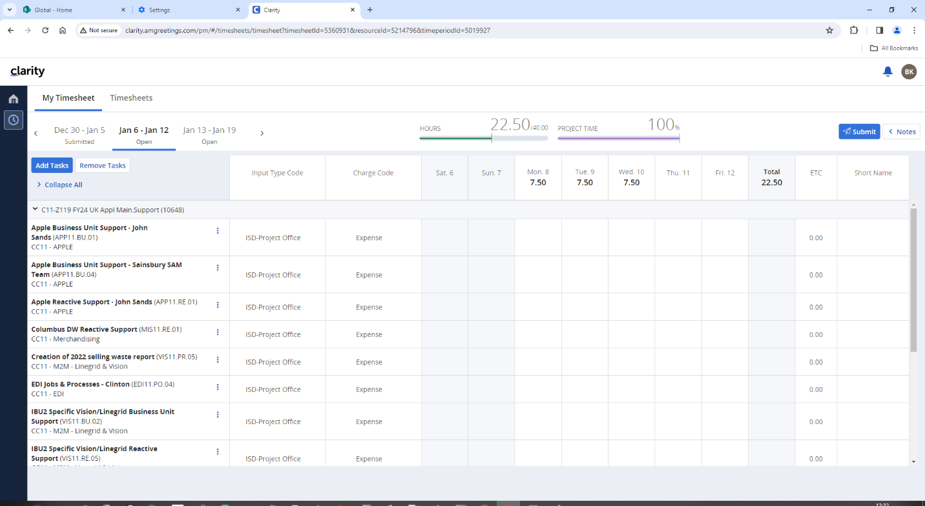

**NOTES:**

* If column headers do not align – maximize and restore down your browser window (or other way round)  ,

alternatively, you can open and close inspection tab (press F12 to open and close it)

* Every time you collapse and expand job list or add a new job to the list you’ll have to click Resize Clarity again.